MySQL Pizza Sales Analysis
1) Create Table
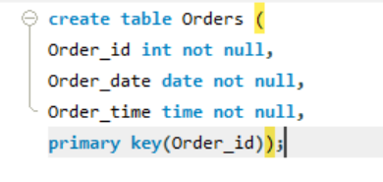
2) Total no of Orders
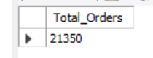
3) Total Revenue
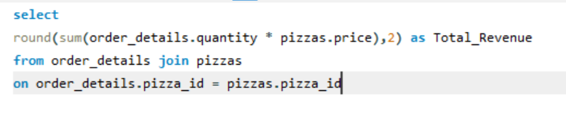
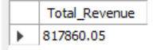
4) Identify the Highest prized pizza

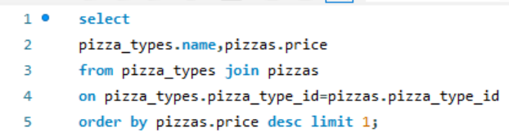
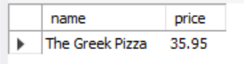
5) Identify the most common pizza size ordered
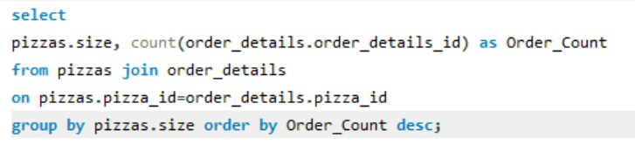
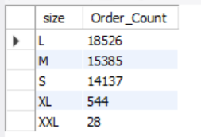
6) List top 5 most ordered pizza types along with their quantities
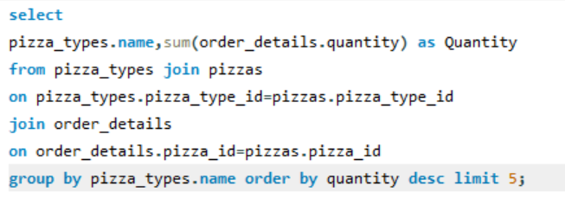
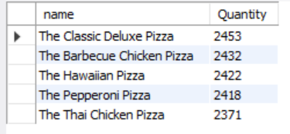
7) Join the necessary tables to find the total quantity and each pizza ordered
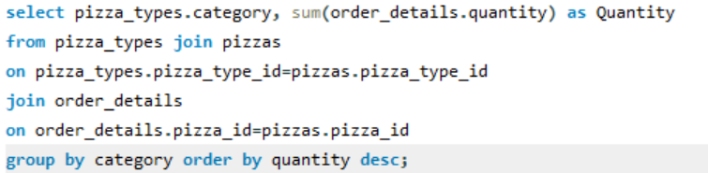
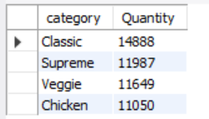
8) Distribution of orders by Hours of the day
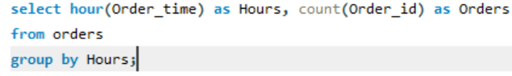
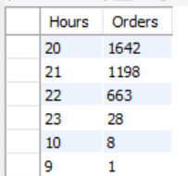

9) Join relevant tables to find the category wise distribution of pizzas
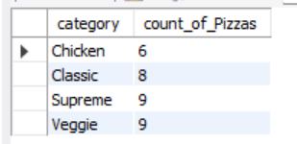
10) Group the orders by date and calculate the average no of pizzas ordered per day
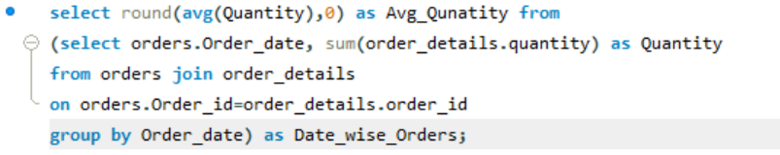
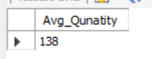
11) Top 3 most ordered pizza types based on revenue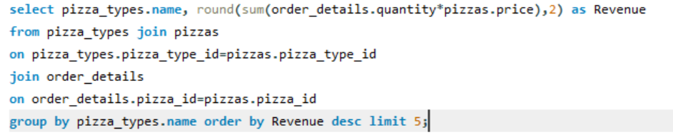
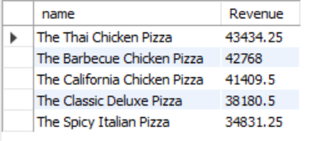
12) Calculate the percentage contribution of each pizza type to total revenue
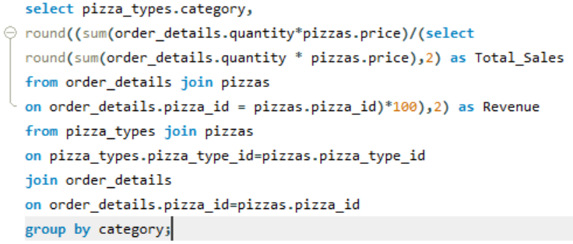
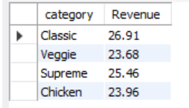
13) Analyse the cumulative revenue generated over time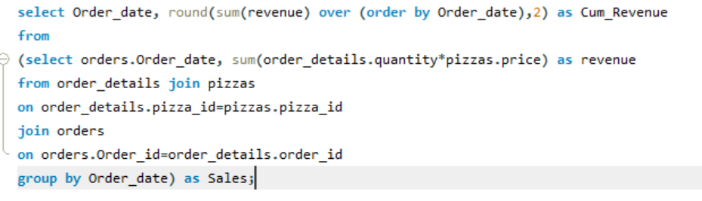
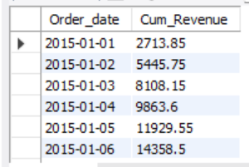
14) Top 3 most ordered pizza types based on revenue for each pizza category